**COMSATS University, Islamabad**

**Assignment # 2**

**Author**

***Muhammad Mujtaba SP22-BSE-036 2A***

**Course**

***Calculus ()***

**Instructor**

***Sir Khurram Shahzad***

**Date**

***Sep 24, 2022***

**Question # 1**

How 1 degrees = 1?

**Solution**

1. 1 degrees cannot be equal to 1 in pure numerical sense. Because it has a unit *degrees* associated with it, while **1** has no units so we cannot assume how much of any quantity **1** represents, for example: 1 quadrant, 1 circle, 1 km, 1 minute, etc etc..

While 1 degrees explicitly represents 1/360th of a full rotation.

**Question # 2**

Why is circle exactly 360 degrees? Why no more or no less?

**Solution**

1. It is a convention adopted by Babylonians.
2. Babylonians did math in base-60 instead of base-10. They divided the circle up into 360 primary parts because 360 is a highly composite number and a multiple of 60. Fractions were invented long before decimals. And 360 can be divided in way more ways than most any other number as an even fraction.
3. Factors of 360 are huge.
4. Also, number of days in a year also coincides with 360, representing the whole orbit of sun.

**Question # 3**

Find:

1. Domain/range of: sin, cos, tan, sec, csc, cot.
2. Graphs of them.
3. Apply theory if they are onto, one-one not onto.
4. Apply tests that if they are one-one or not, why?

**Solution**

1. Domain of ***sin*** is (-∞, ∞) and Range of *sin* is [-1, 1]. Horizontal line cuts the function in more than one point, so it is not one-one function.

If it is R -> R function, than it is not onto as its image is just the interval [−1,1].

1. Domain of ***cos*** is (-∞, ∞) and Range of *cos* is [-1, 1]. Horizontal line cuts the function in more than one point, so it is not one-one function. Graph same as sin but with phase difference.

If it is R -> R function, than it is not onto as its image is just the interval [−1,1].

1. Domain of ***tan*** is {x∣∣x≠π2+πn} and Range of *tan* is (-∞,∞). Restricted tan between (-PI/2, PI/2) passes horizontal line test so is one one, but otherwise it is not one-one. It is an onto function.

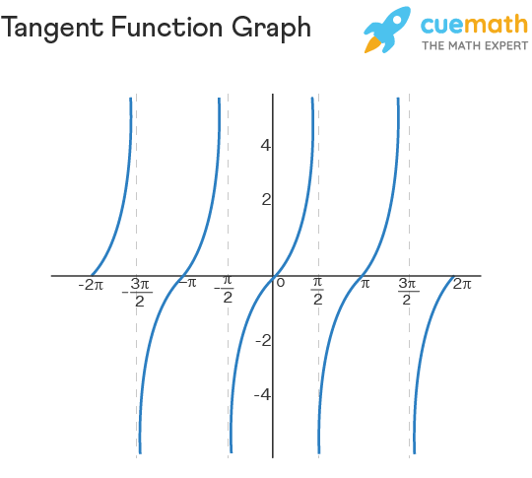

1. Domain of **sec** function: R - (2n + 1)π/2 Range of secant function: (-∞,-1] U [1, ∞). It is not one-one as it fails horizontal line test and is periodic. It is not onto either.
2. Domain of **csc** = R - nπ Range = (-∞, -1] U [+1, +∞). It fails horizontal line test, so not 1-1. And it is not onto either.
3. The domain of **cot** x is R - {nπ} and its range is R

